**Name: Ali Abdullah**

**Reg No: 2021-CE-40**

**Course: Data Base Management Systems**

**Question1:**

**ScreenShot of ER Diagram:**

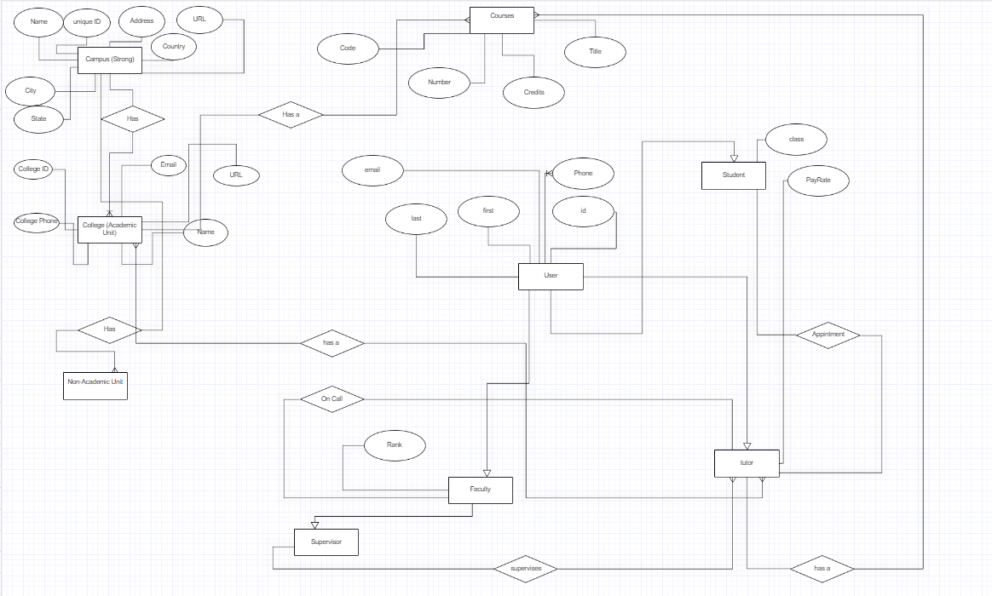

**Question: 2**

**Screenshot of ER Diagram:**

**Question: 3**

**Screenshot of ER Diagram:**

a) Supply (min, max) constraints on this diagram:

b) Under what conditions would the relationship HAS PHONE be redundant in this example?

The relationship "HAS PHONE" would become redundant if we can directly associate phones with employees through the "WORKS IN" relationship. if we remove the "HAS PHONE" relationship and still maintain the ability to determine which phones belong to which employees through their department assignments, then the "HAS PHONE" relationship is redundant.

So, under normal conditions, the "HAS PHONE" relationship is not redundant, as it explicitly associates phones with employees, ensuring that each employee can have their assigned phones, which may not necessarily be the same as the department's phones.